Predicting California Housing Prices with Linear, Ridge, and Lasso Regression
Joaquin Hidalgo-Estrada
Introduction
.
The objective of this study is to build and evaluate predictive models of housing prices in California, with the goal of identifying the most effective approach for estimating prices based on features that customers may want or need. Beyond the practical importance of understanding housing price dynamics, this project also serves as an opportunity to gain hands-on experience using the R programming language for statistical modeling and analysis.
Our approach begins with a baseline multiple linear regression model to establish a foundation for prediction. Recognizing the potential limitations of ordinary least squares, particularly when dealing with multicollinearity and complex relationships among predictors, we then extend the analysis to regularized regression methods. Specifically, ridge regression (L2 regularization) and lasso regression (L1 regularization) are employed to improve predictive accuracy and assess the benefits of coefficient shrinkage and variable selection. By comparing these methods, we aim to determine which model provides the best predictive performance for California housing prices.

Data Description

The dataset used in this analysis was retrieved from Kaggle (California Housing Prices), but it was originally introduced in Pace, R. Kelley, and Ronald Barry (1997), "Sparse spatial autoregressions," Statistics & Probability Letters, 33(3): 291–297.
The dataset contains 20,640 observations and 10 variables describing housing blocks in California. The variables are:
- longitude – how far west a house is located (higher value = farther west).
- latitude – how far north a house is located (higher value = farther north).
- housing_median_age – median age of a house within a block (lower values = newer homes).
- total_rooms – total number of rooms within a block.
- total_bedrooms – total number of bedrooms within a block.
- population – number of people residing within a block.
- households – number of households (groups of people in a housing unit) in a block.
- median_income – median income of households in a block (in tens of thousands of USD).
- median_house_value – median house value for households in a block (in USD).
- ocean_proximity – categorical variable describing proximity to the ocean/sea.
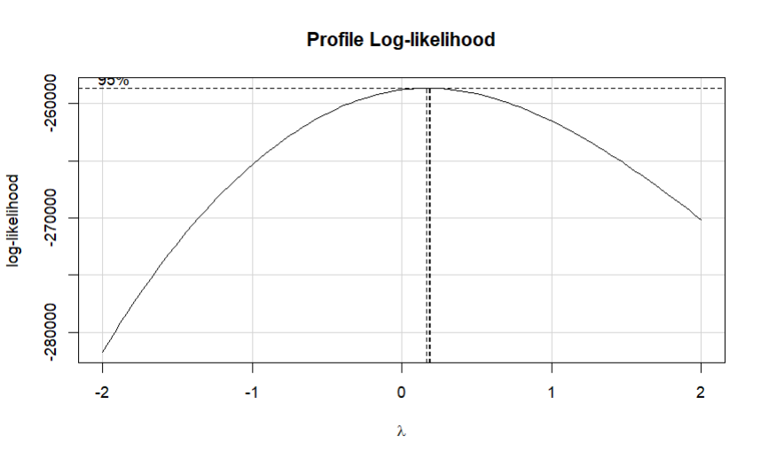
The response variable in this study is median_house_value. Using a BoxCox test the response was transformed to $y^{\frac{1}{4}}$ due high heteroscedasticity during initial attempts to fit a model.

Preprocessing steps included:
- Cleaning the dataset by removing rows with missing values (these represented only a negligible portion of the dataset).
- An 80/20 train-test split was performed to evaluate predictive performance, with set.seed(1) applied to ensure replicability of results.
- Applying standardization to predictor variables to ensure all features are on a comparable scale, which is particularly important for regularization methods such as ridge and lasso regression.
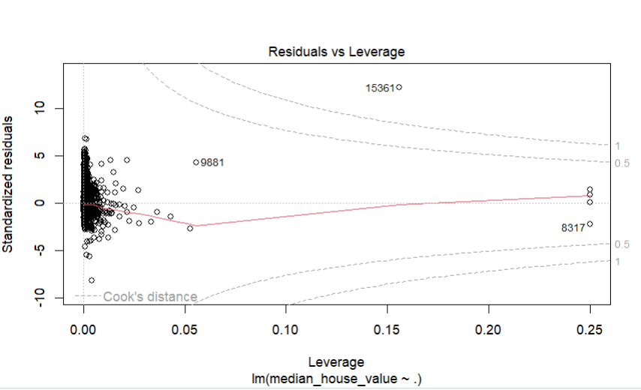
- Cook’s Distance was applied to detect highly influential observations. Points exceeding the threshold were removed to prevent distortion of model estimates. No further outliers were excluded, as the remaining values were deemed plausible within the context of California housing data.

- No further transformations were applied apart from the response transformation.
- Categorical variables, such as oceanProximity, were automatically converted to dummy (one-hot) variables by R using model.matrix() to allow inclusion in the regression models.
- Predictors were checked for multicollinearity using Variance Inflation Factors (VIF). Highly correlated variables were considered for removal to improve model stability, particularly for the linear regression model.

Methodology

All analyses were conducted in R using the following packages: car, MASS, olsrr, ISLR, Metrics, and glmnet.
Baseline Model: A multiple linear regression (OLS) model was first fit to establish an initial benchmark and evaluate baseline performance. To refine the model, a stepwise selection algorithm was applied, using a significance level of 0.1 for both variable entry and removal. This approach was chosen to reduce the number of predictors, improve interpretability, and identify the subset of variables most strongly associated with housing prices. Predictors with high Variance Inflation Factors (VIF) were also removed to address multicollinearity and improve model stability.
Regularized Models: Ridge regression (L2 regularization) and Lasso regression (L1 regularization) were then applied. Unlike OLS, predictors were not removed manually; instead, the models penalized large coefficients to handle multicollinearity and reduce overfitting. The performances of these models were compared with OLS to identify the best predictive approach. Regularization is expected to improve results, particularly in datasets with correlated predictors.
Model Selection: Hyperparameter tuning was conducted via cross-validation to select the optimal penalty parameter lambda (λ) for both ridge and lasso regression. A fixed random seed set.seed(1) was used to ensure replicable and generalizable performance.
Evaluation Metrics: Model performance was assessed using Mean Squared Error (MSE) on both the training and test sets. For consistency, MSE was calculated on the transformed response variable scale $y^{\frac{1}{4}}$, which stabilizes variance.

Results

Linear Regression (Baseline Model):
The multiple linear regression model (with stepwise selection) yielded a training MSE of 3.0895 and a test MSE of 3.1610, with an adjusted R² of 0.636. While the baseline model provided a reasonable fit, issues such as multicollinearity (addressed via VIF-based variable removal) and signs of residual non-normality were observed. These limitations motivated the use of regularized regression methods.

Ridge Regression:
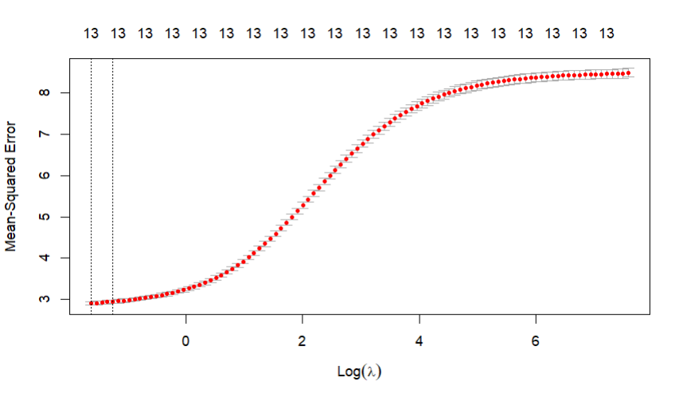
Using cross-validation for hyperparameter tuning, the optimal penalty parameter was found to be λ = 0.1967. Ridge regression achieved a training MSE of 2.8985 and a test MSE of 2.9789. The model retained all predictors while shrinking coefficients toward zero, effectively mitigating multicollinearity without eliminating variables.

Lasso Regression:
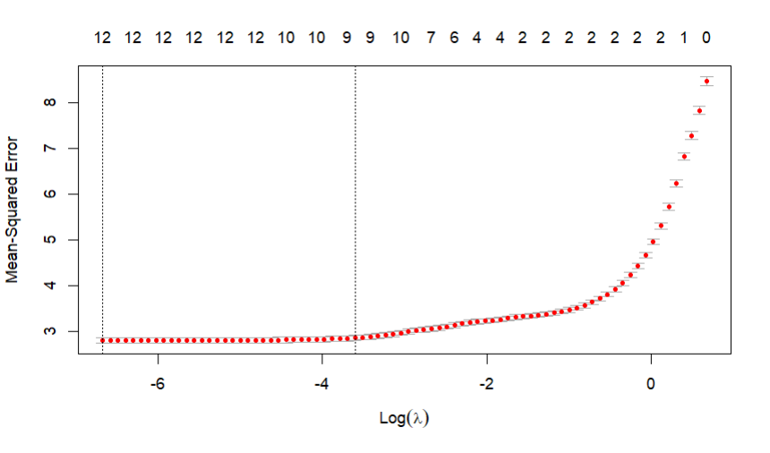
Cross-validation identified the optimal penalty parameter as λ = 0.0013. Lasso regression yielded a training MSE of 2.7967 and a test MSE of 2.8863, outperforming both ridge and the baseline linear regression. Unlike ridge, lasso performed variable selection by driving some coefficients to zero, resulting in a more parsimonious model with improved generalization.

MSE Comparison:
Model | Train MSE | Test MSE | Adj. R²
Linear Regression | 3.0895 | 3.1610 | 0.636
Ridge Regression | 2.8985 | 2.9789 | --
Lasso Regression | 2.7967 | 2.8863 | --

- All reported MSE values correspond to the transformed response variable $y^{\frac{1}{4}}$.
- Both ridge and lasso improved upon the baseline linear regression in terms of lower train and test MSE, demonstrating the benefit of regularization.
- Lasso regression achieved the lowest test error (2.8863), while also performing variable selection, suggesting that it provides the best balance between predictive accuracy and model parsimony for this dataset.
- The ridge regression also improved generalization, though its test error was slightly higher than lasso’s.
Coefficient Analysis:
Examining the estimated coefficients across models highlights the different ways linear regression, ridge, and lasso handle predictor variables:
- Linear Regression: All predictors are retained, but due to multicollinearity some coefficients are large in magnitude and unstable.
- Ridge Regression: Coefficients are shrunk toward zero, but none are eliminated. This reduces variance and stabilizes the model while maintaining all predictors.
- Lasso Regression: Some coefficients are shrunk all the way to zero, performing automatic variable selection. This yields a sparser, more interpretable model.

Table 1: Comparison of Coefficients Across Models
Predictor | Linear Coefficient | Ridge Coefficient | Lasso Coefficient
(Intercept) | 21.53170 | 20.71842412 | 21.172914749
longitude | -0.08762 | -0.55807491 | -1.323915935
latitude | -- | -0.56193723 | -1.376099814
housing_median_age | 0.23630 | 0.21277341 | 0.205812788
total_rooms | 0.72669 | 0.06877849 | -0.019077199
total_bedrooms | -- | 0.39992849 | 0.632899436
population | -0.56873 | -0.67900791 | -0.952446405
households | -- | 0.38821850 | 0.493887996
median_income | 1.57253 | 1.59715501 | 1.690049011
ocean_proximity<1H OCEAN | -- | 0.65398365 | 0.077502362
ocean_proximityINLAND | -2.58273 | -1.40648503 | -1.524160214
ocean_proximityISLAND | 4.18218 | 4.37784850 | 3.136334736
ocean_proximityNEAR BAY | -0.06753 | 0.63083509 | -0.005834527
ocean_proximityNEAR OCEAN | 0.13635 | 0.70411188 | --

- Median income is the strongest positive predictor across all models, confirming its dominant role.
- Population consistently shows a strong negative effect, amplified under lasso.
- Spatial variables (longitude, latitude) become more influential under ridge and lasso, suggesting location effects matter once multicollinearity is controlled.
- Total rooms is important in linear regression but largely eliminated by lasso, with bedrooms and households retained instead — highlighting redundancy among housing size measures.
- Ocean proximity matters, especially INLAND (negative) and ISLAND (positive). Lasso drops less-informative categories (e.g., NEAR OCEAN).
- Regularization impact:
  - Ridge spreads effects across correlated predictors.
  - Lasso enforces sparsity, selecting the most relevant subset of predictors while maintaining accuracy.

Conclusion

Predictive modeling of California housing prices demonstrated that regularization substantially improves performance compared to baseline linear regression. Both ridge and lasso regression reduced train and test MSE, effectively controlling for multicollinearity and overfitting. Lasso regression achieved the lowest test MSE (2.8863) and performed variable selection, resulting in a parsimonious model with strong predictive accuracy, while ridge regression also improved generalization, though its test error was slightly higher. Median income emerged as the most influential positive predictor, and population consistently exhibited a negative effect. Housing characteristics such as bedrooms and households, along with spatial variables like longitude, latitude, and ocean proximity, contributed meaningfully to predictions, with ridge and lasso adjusting their relative importance through shrinkage and variable selection. Linear regression highlighted a few strong predictors but was affected by multicollinearity, ridge distributed effects across correlated predictors for stability, and lasso produced a sparse, interpretable model without sacrificing predictive power. All reported MSE values correspond to the transformed response variable $y^{\frac{1}{4}}$., ensuring stabilized variance. Overall, lasso regression provides the best balance of accuracy, interpretability, and model simplicity for predicting California housing prices.

